Controls – Parts and Software Research

The research will be broken down into two sections, the first section will be the sensors and actuators, and the second section will be the board, controller and software suite that could be used.

# Sensors and Actuators:

Image Recognition:

* Image classification and object detection, the goal is to determine quickly what the object is
  + If the object they are recycling is part of a consumer product (household) it will be easy to recognize and easy to detect.
  + We want to have this easy for the general public to use, and most of the things that they will be recycling will be easily recognizable

Infra-red:

* Rapid recognition and reliable separation of six different plastics at the same time
  + Do we need to sort between the different plastics currently, or let the plants do that? (My vote is on the plants doing that!)
* According to the paper (cited below) a simple LD based system would be able 3800 pounds and would have a lifetime of 100,000 hours and power dissipation of about 5W but the cost of this option will limit or cancel this option from our project

Touch System:

* Can determine if the object is metal based on the conductivity sensors as well as the amount of force that is needed to lift/crush the object to know the material
* They plan to add image recognition to the robot to determine objects more clearly and also have problems if objects are not separated

# Board, Controller and Software Suite:

Jetson Nano

* Delivers 472 GFLOPS of compute performance consuming as little as 5 watts
* Supports many popular AI frameworks, easy to integrate their preferred models and frameworks into the product
* Supports high-resolution sensors
* JetPack SDK – with accelerated libraries for deep learning and computer vision

Hello AI World

* Provides the framework for the simple image recognition with the ability to add more objects as needed which would be needed for the project to determine what it is and if it is recyclable

GPIO Pins

* Jetson Nano is includes with 40 pin header which various GPIO pins including Special Io Functionality

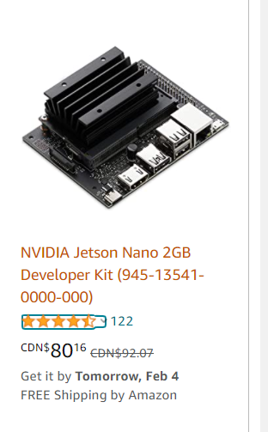

Open MV

* Python Powered, low cost machine vision modules and aims at becoming the “Ardunio of Machine Vision”
* Can track colours, detect faces, and more in seconds and then control I/O pins in the real-world
* The OpenMV Cam uses less than 200mA of power while processing images so that you can use it as a microcontroller.
* Cloud Based – Not ideal as a locally stored solution
* Would need to start adding multiple shields to add Motors, Wifi, LED, Storage....

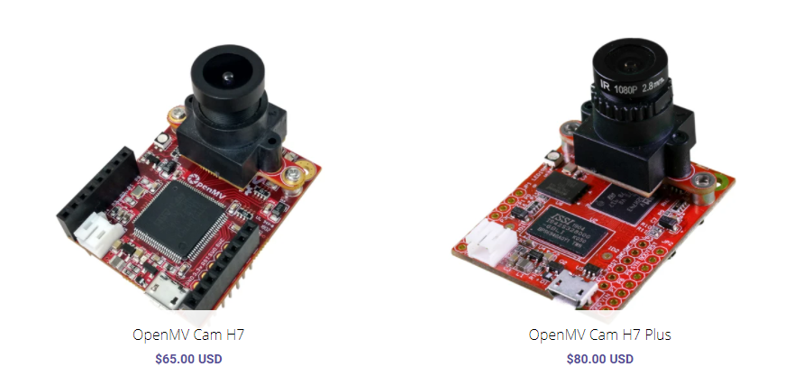

TensorFlow

* ML framework that supports deep learning and neural networks, plus it is open source to help with that project
* Able to run on lighter power devices but prefer the heavier computers with more processing power
* Able to be run on a Raspberry Pi or Jetson Nano or other simular device

# Sources:

<https://nvidianews.nvidia.com/news/nvidia-announces-jetson-nano-99-tiny-yet-mighty-nvidia-cuda-x-ai-computer-that-runs-all-ai-models>

<https://itsfoss.com/nvidia-jetson-nano/>

<https://openmv.io/>

<https://hackernoon.com/9-things-you-should-know-about-tensorflow-9cf0a05e4995>

<https://www.eurekamagazine.co.uk/design-engineering-features/technology/sensors-identify-plastics-for-recycling/29331/>

<https://www.environmentalleader.com/2015/07/sensor-based-sorting-revolutionizes-plastics-recycling/>